**3.8.1 Exercises**

1. What is the problem with this plot? How could you improve it?

**ggplot**(data = mpg, mapping = **aes**(x = cty, y = hwy)) +

**geom_point**()

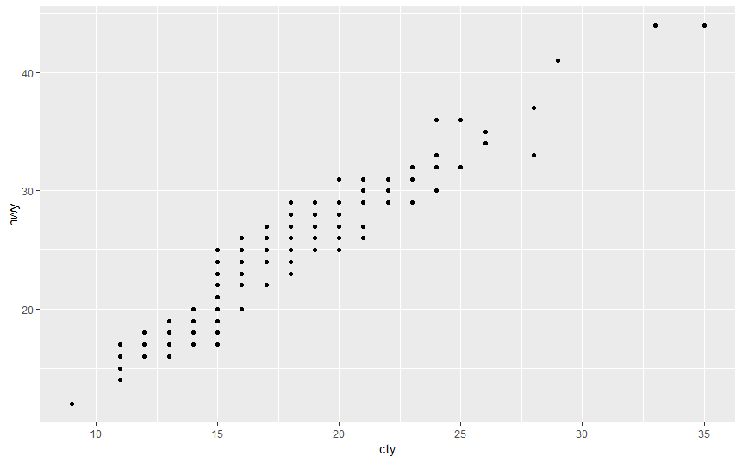

There is a problem of over plotting because there are multiple combinations for each hwy and cty which can be solved by using “positon=jitters”

ggplot(data = mpg, mapping = aes(x = cty, y = hwy)) +

geom_point(position="jitter")

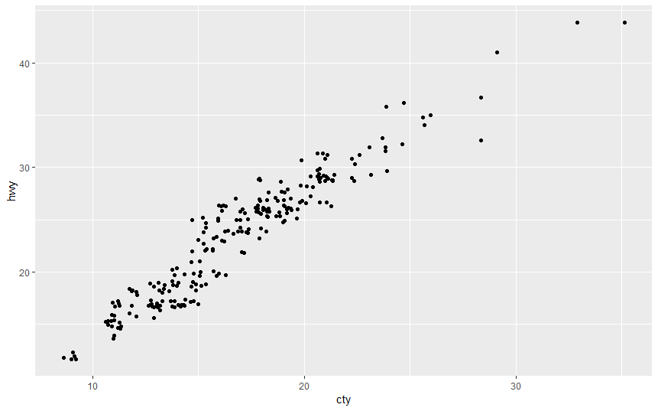

1. What parameters to geom_jitter() control the amount of jittering?

`width’ controls for vertical displacement.

`height’ controls for horizontal displacement.

Examples

No horizontal jitter

ggplot(data = mpg, mapping = aes(x = cty, y = hwy)) +

geom_jitter(width = 0)

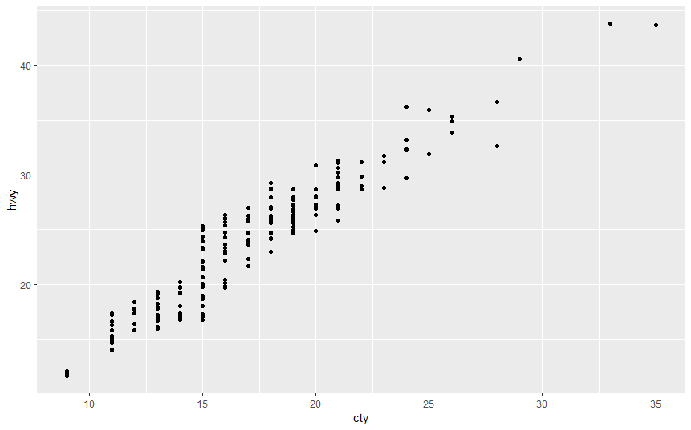

Too much horizontal jitter

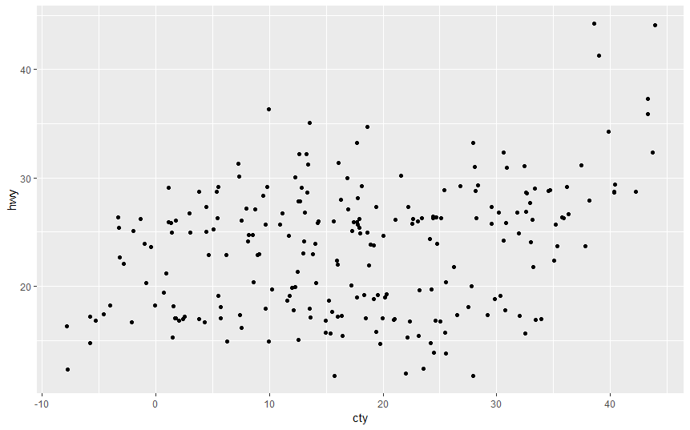

No horizontal Jitter

ggplot(data = mpg, mapping = aes(x = cty, y = hwy)) +

geom_jitter(height = 0)

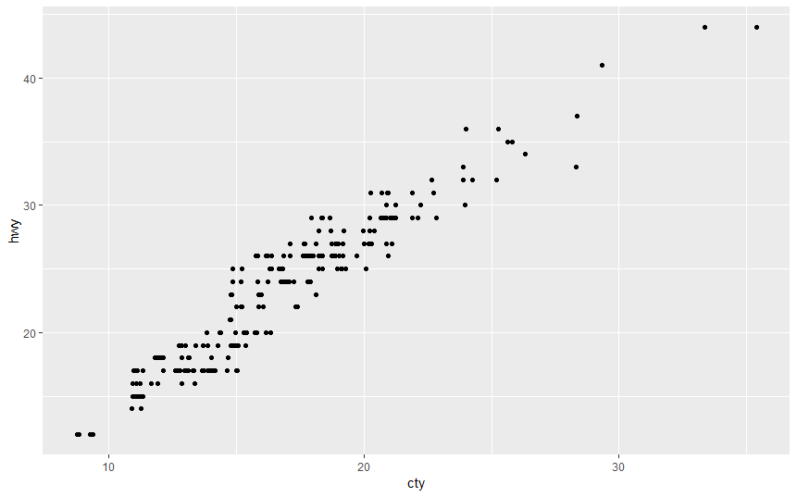

Too much horizontal jiiter

ggplot(data = mpg, mapping = aes(x = cty, y = hwy)) +

geom_jitter(height = 15)

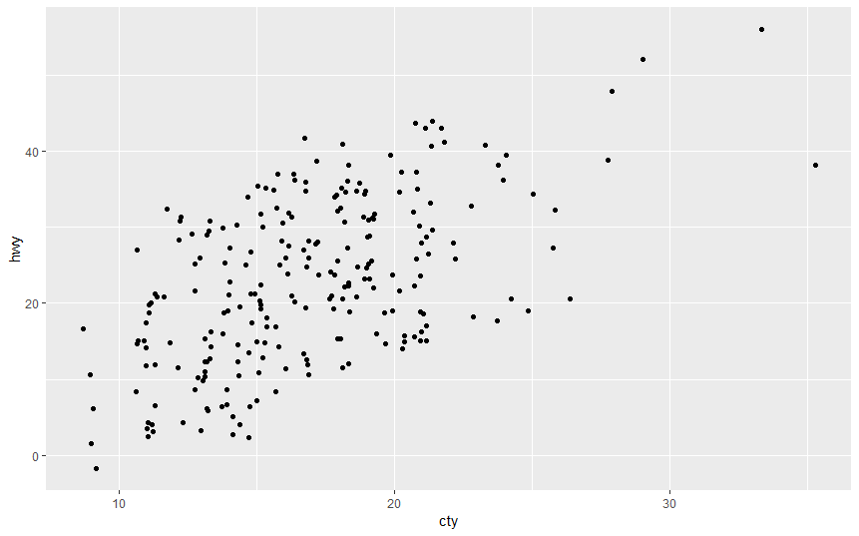

For normal plot as in geom_point in qn. 1

ggplot(data = mpg, mapping = aes(x = cty, y = hwy)) +

geom_jitter(height = 15)

1. Compare and contrast geom_jitter() with geom_count().

The geom_jitter() adds random variations to the location of points on the plot (jittering) ,this reduces over plotting.

ggplot(data = mpg, mapping = aes(x = cty, y = hwy)) +

geom_jitter()

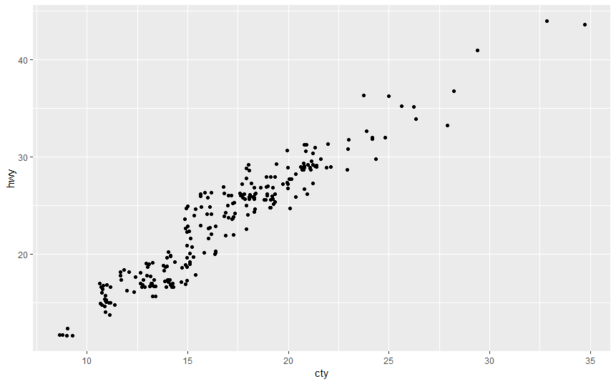

The geom_count sizes the points the points relative to the number of observations.

Combinations of (`x`, `y`) values with more observations will be larger than those with fewer observations.

#geom_count

ggplot(data = mpg, mapping = aes(x = cty, y = hwy)) +

geom_count()

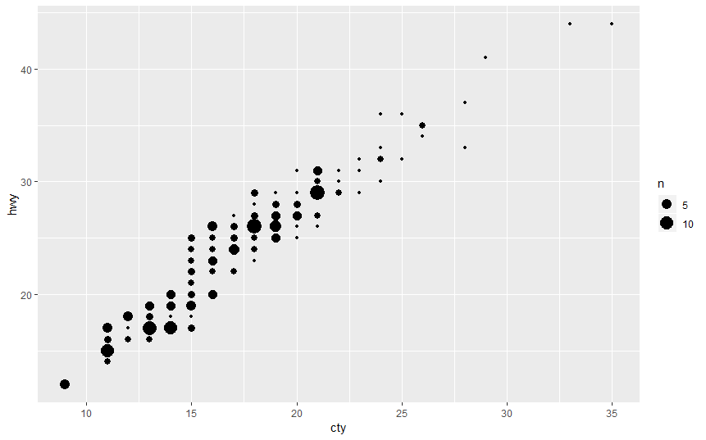

1. What’s the default position adjustment for geom_boxplot()? Create a visualisation of the mpgdataset that demonstrates it.

The default position for geom_boxplot() is dodge2, which is a shortcut for position_dodge2.

ggplot(data = mpg, aes(x = drv, y = hwy, colour = class)) +

geom_boxplot()

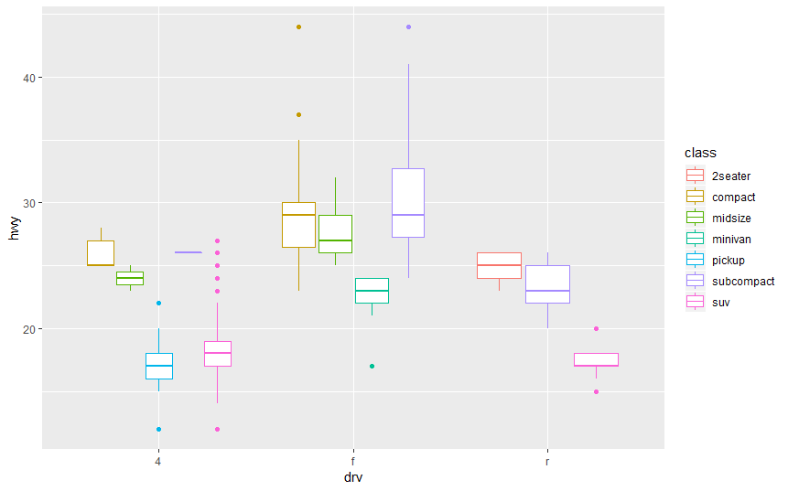

#Boxplots & position identity

ggplot(data = mpg, aes(x = drv, y = hwy, colour = class)) +

geom_boxplot(position = "identity")

